Smart Learning Application
How To Use

The Main Dashboard

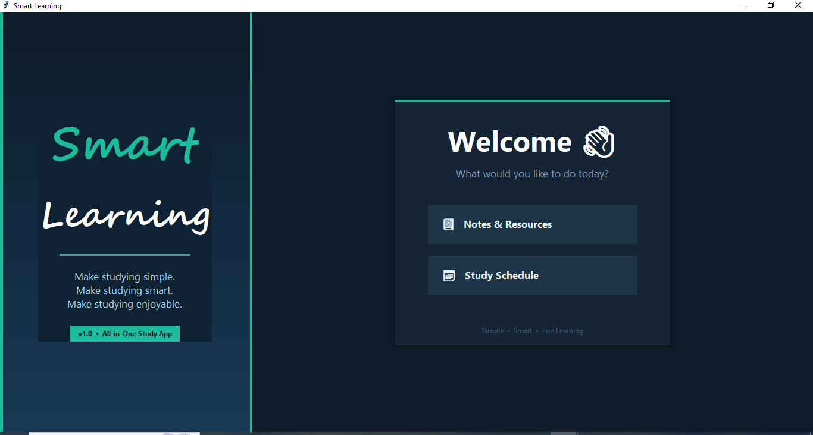

🎓📅 SMART LEARNING- NOTES & Resources Module

📘 How to Use the “Notes / Resource Finder” Feature

🔹 Step 1: Open the Notes Section
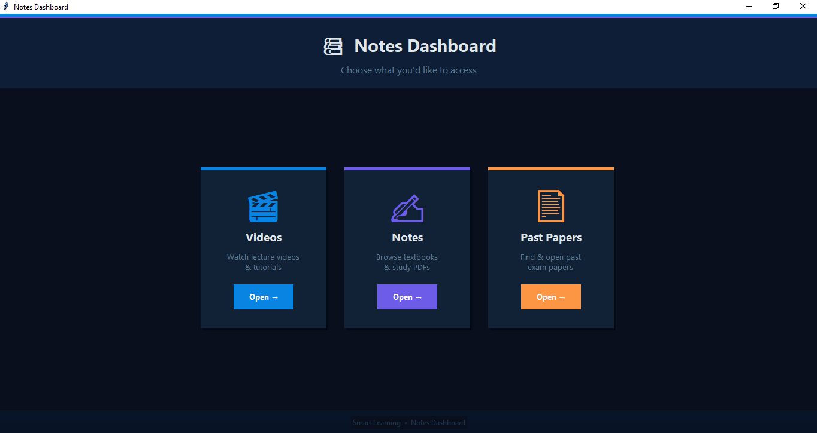
- Open the Notes / Resource Finder from your dashboard.
- You will see a form with options like:
  - Education Level
  - Class / Degree
  - Subject
  - Topic

🔹 Step 2: Select Education Level
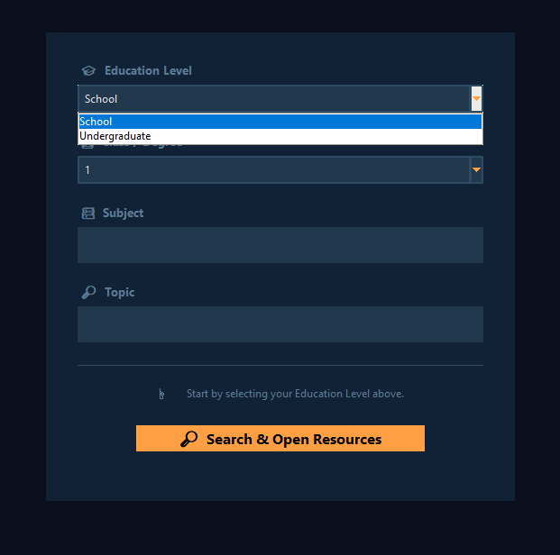
- Click on Education Level
- Choose your level (Example: School, Undergraduate, etc.)
- This step is important because it filters all data based on your level

🔹 Step 3: Select Class / Degree
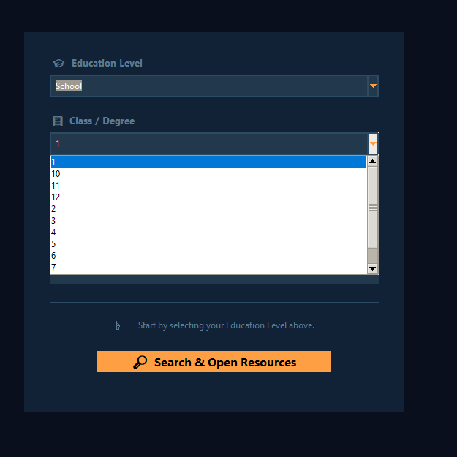
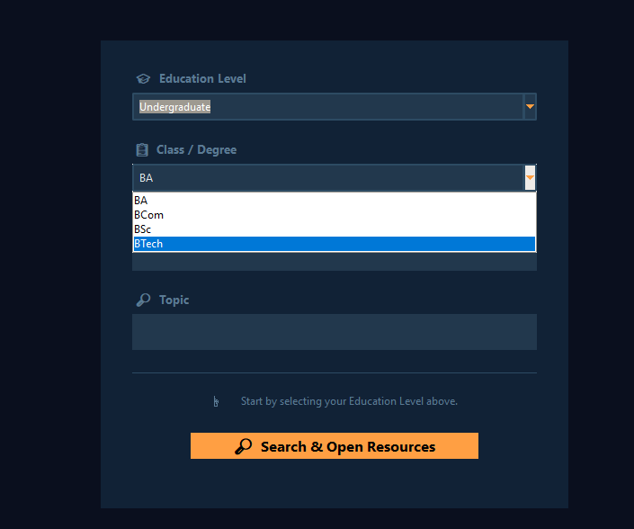

- After selecting the level, the Class/Degree options will update automatically
- Choose your class (Example: BTech, Class 10, etc.)

🔹 Step 4: Enter Subject
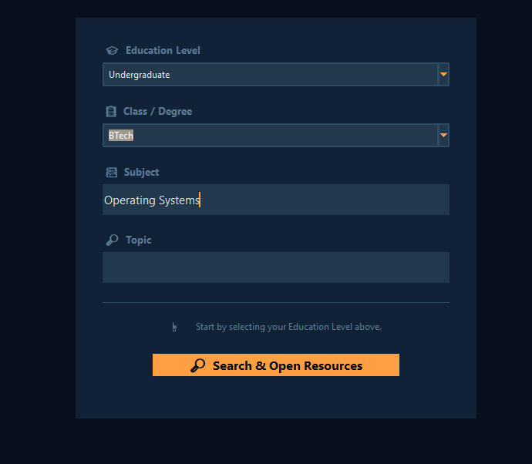
- Type your subject name
- Example: Operating Systems
- You don’t need to type the exact full name — partial names also work

🔹 Step 5: Enter Topic
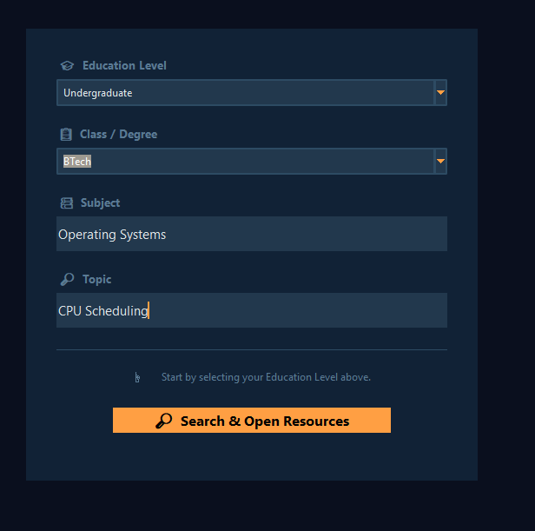
- Type the topic you want
- Example: CPU Scheduling
- This helps in finding more accurate resources

🔹 Step 6: Click Search

- Click on “Search & Open Resources”
- The system will find matching study materials from the database

🔹 Step 7: View Results
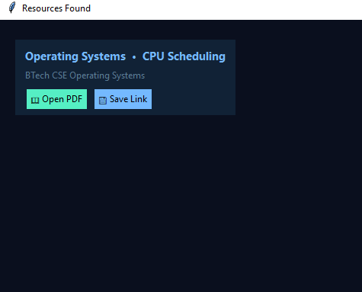
- A new window will open showing available resources
- Each result contains:
  - Subject + Topic
  - Book / Material Name

🔹 Step 8: Use the Buttons
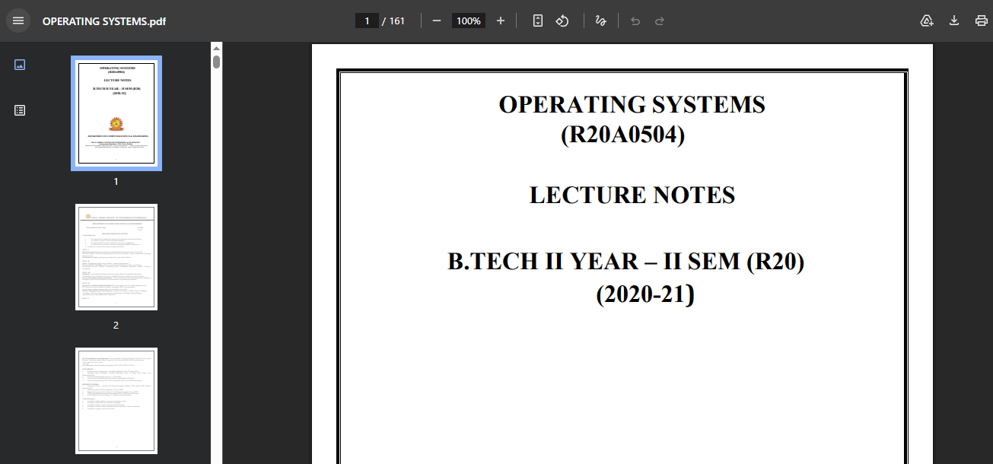
For each resource, you get two options:
✅ Open PDF
- Opens the study material directly
💾 Save Link
- Saves the link for later use

🔹 Step 9: If No Results Found
- You will see a message: “No study resources found”
- Try:
  - Changing topic spelling
  - Using simpler keywords
  - Removing topic and searching only by subject

✨ Key Features (Simple)
- Smart filtering based on your level and class
- Fast search using subject & topic
- Direct PDF access
- Save links for later
- Clean and easy interface

📄 How to Use the Past Papers Finder Feature
🔹 Step 1: Open the Past Papers Section

-Open the Past Papers Finder from your dashboard.
-You will see options like Education Level, Class or Degree, Subject, and Year.

🔹 Step 2: Select Education Level
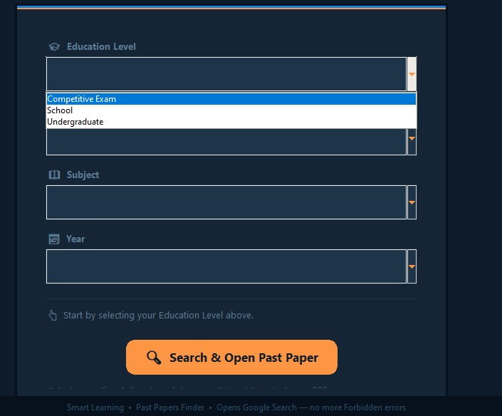
-Click on Education Level and choose your level such as School or Undergraduate.
- This helps filter the data correctly.

🔹 Step 3: Select Class or Degree
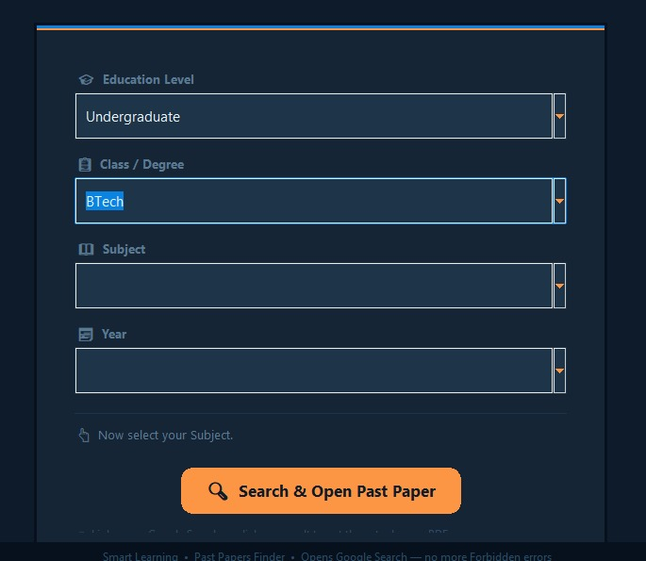
-After selecting the level, the Class or Degree options will update automatically. -Choose your class such as BTech or Class 10.
🔹 Step 4: Select or Type Subject
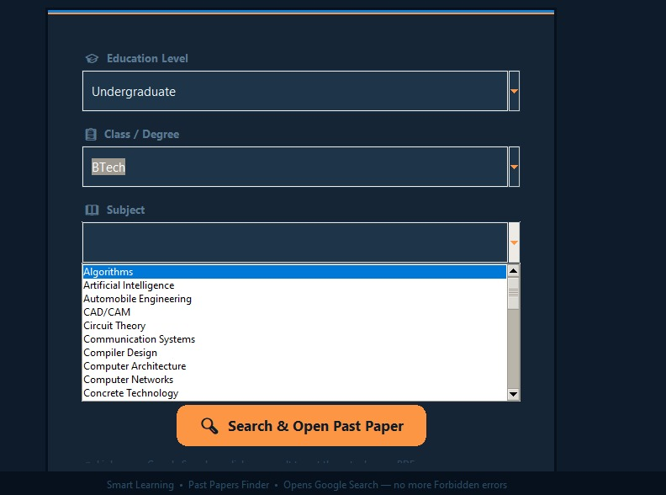
Choose your subject from the dropdown or type it manually.
Example: Operating Systems
The system will also suggest subjects as you type.
🔹 Step 5: Select Year
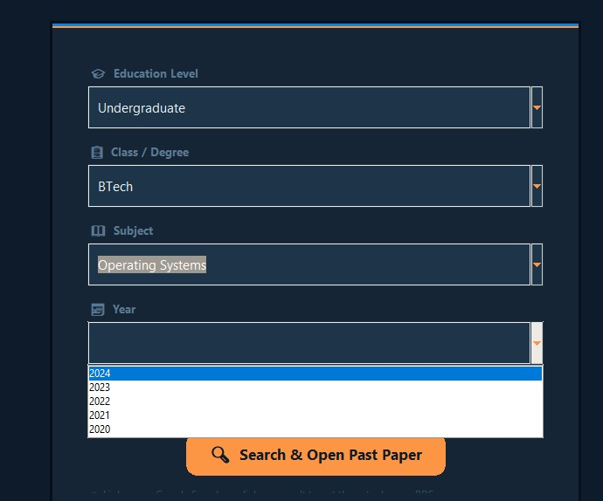
Choose the year of the question paper.
Example: 2023 or 2022-2023
This helps in finding papers from a specific year.
🔹 Step 6: Click Search
Click on “Search and Open Past Paper”. The system will search for the matching paper.
🔹 Step 7: View Result
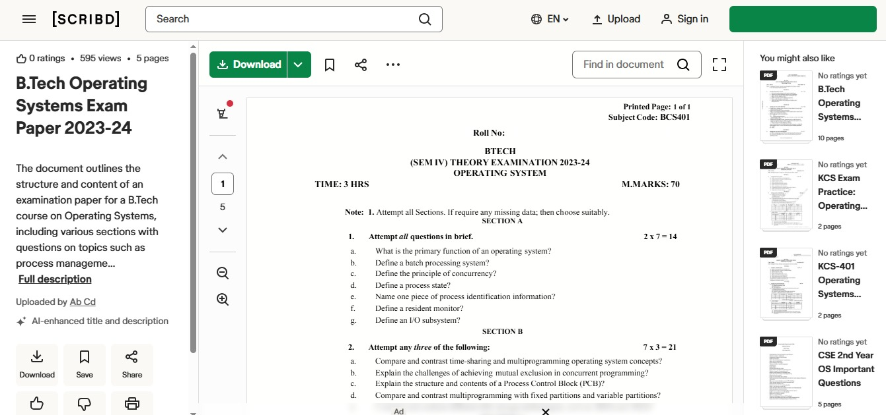
If a match is found, your browser will open automatically with a Google search page related to the selected paper.
🔹 Step 8: If No Results Found
If no matching paper is found, a message will be shown. Try selecting options from the dropdown instead of typing or check if the subject and year are correct.
✨ Key Features
This feature filters results based on education level, class, subject, and year. It allows both typing and selecting subjects. It opens Google search automatically for easy access to papers. The interface is simple and easy to use.

🎬 How to Use the Video Search Feature
🔹 Step 1: Open the Video Section

Open the Video Search feature from your dashboard. You will see a search bar and an option to upload notes or a PDF.

🔹 Step 2: Enter Topic
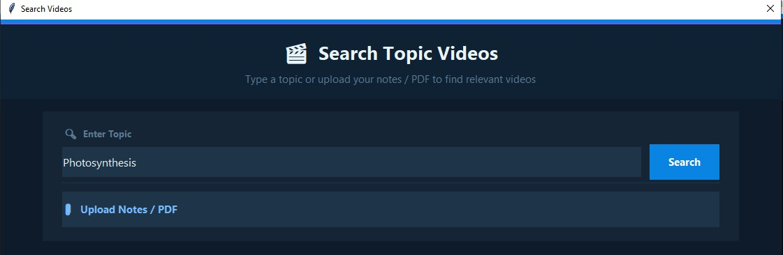
(📸 Insert Image 2: Topic Input Field)
Type the topic you want to learn.
Example: CPU Scheduling
You can enter any subject or concept.
🔹 Step 3: Click Search
Click on the Search button. The system will start finding relevant videos for your topic.
🔹 Step 4: Wait for Results
A message will appear saying “Searching videos, please wait…”
The system searches different types of videos like full lectures, beginner guides, and revision videos.
🔹 Step 5: View Video Results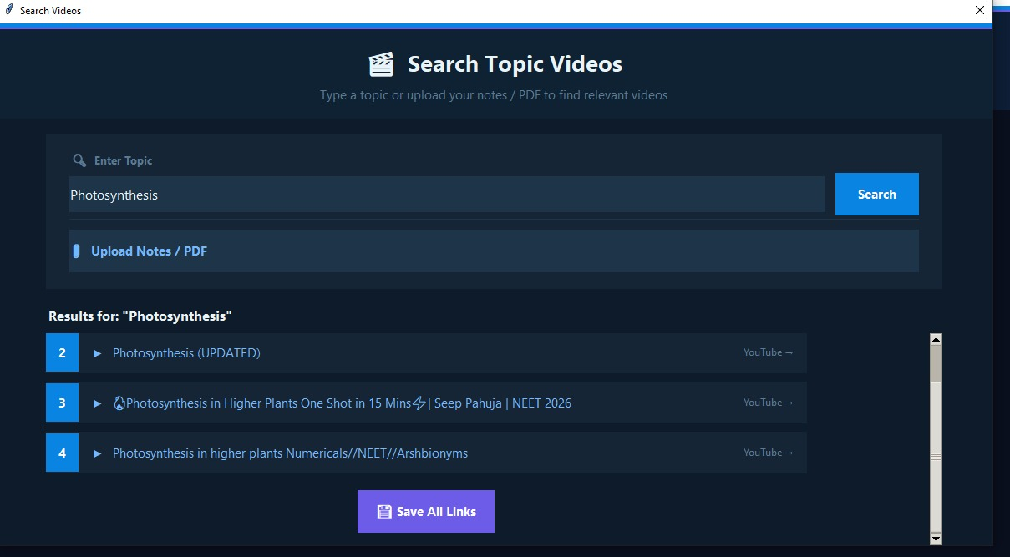
You will see a list of videos with titles. Each video represents a different type of learning content.
🔹 Step 6: Open a Video
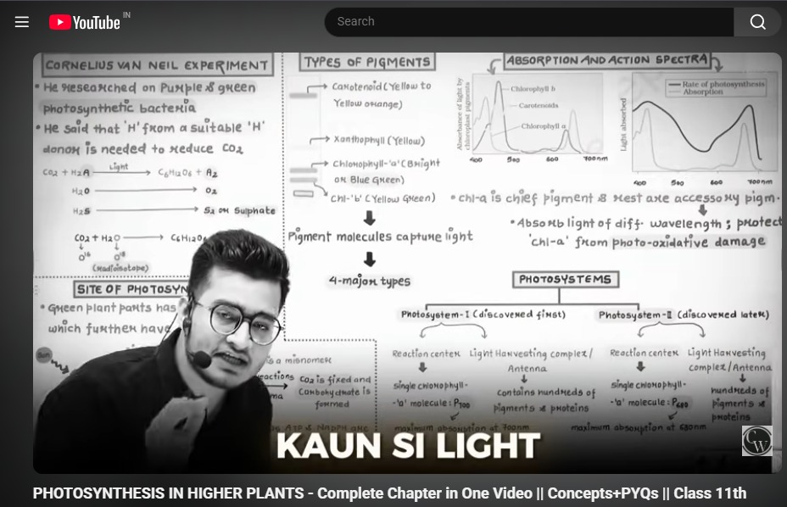
Click on any video title. It will open directly in your browser (YouTube).
🔹 Step 7: Save All Video Links
Click on “Save All Links” to save all video links into a PDF file.
You can use this later for quick access.
🔹 Step 8: Upload Notes or PDF (Optional)
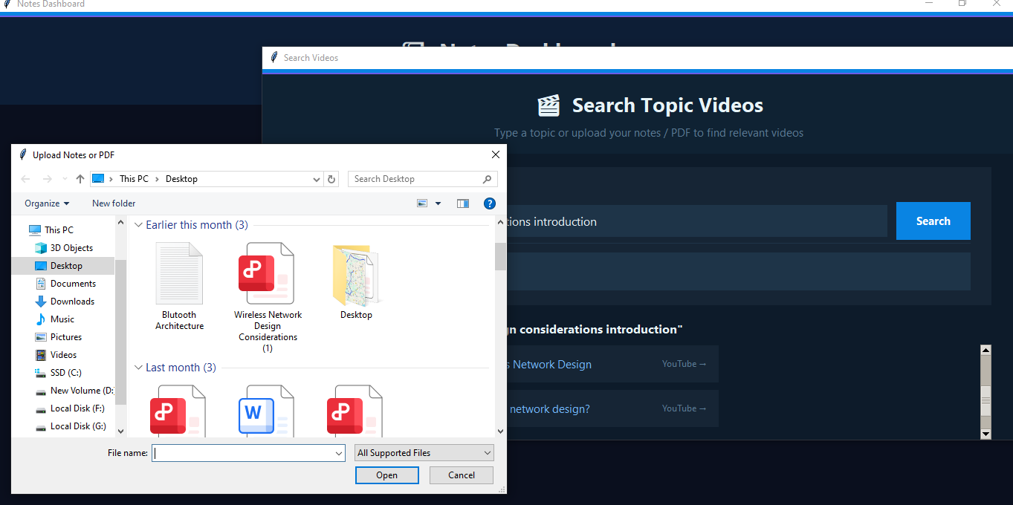
Click on “Upload Notes / PDF” if you don’t know what to search.
Select your file, and the system will automatically extract keywords and search videos based on your notes.
🔹 Step 9: If No Results Found
If no videos are found, a message will appear.
Try using a different topic or simpler keywords.
✨ Key Features
- Search videos using topic name
- Automatically finds different types of learning videos
- Clickable links that open directly in browser
- Save all video links in a PDF file

🎓📅 SMART LEARNING – SCHEDULE MODULE (USER GUIDE)

🚀 STEP 1: Open the Application
- Run the program ▶️
- Main screen will appear
- Click on “Study Schedule”
📸 [IMAGE 1: MAIN SCREEN]
Caption: Figure 1 – Application Home Screen showing main options

📌 STEP 2: Choose an Option
You will see three options:
- 🆕 Create New Schedule
- 👁 View Existing Schedule
- 📊 Analyze Timetable
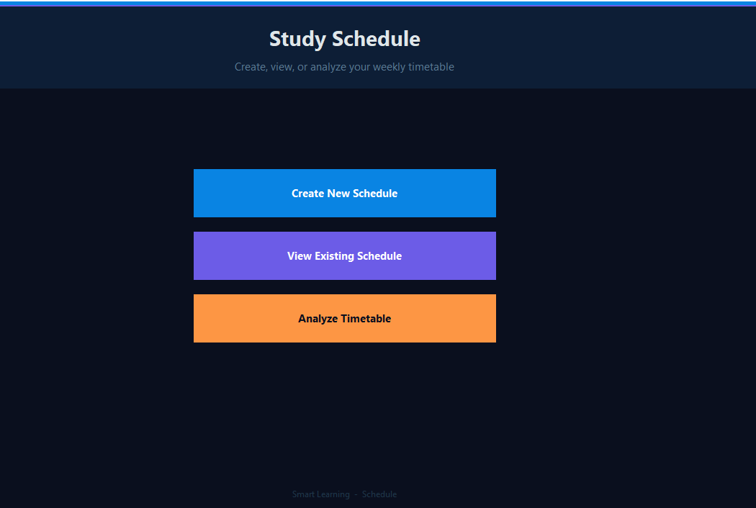

🆕 OPTION 1: CREATE NEW SCHEDULE

✏️ STEP 3: Enter Subject Details
- Enter number of subjects
- Click “Add Subject Fields”
- Fill each subject name
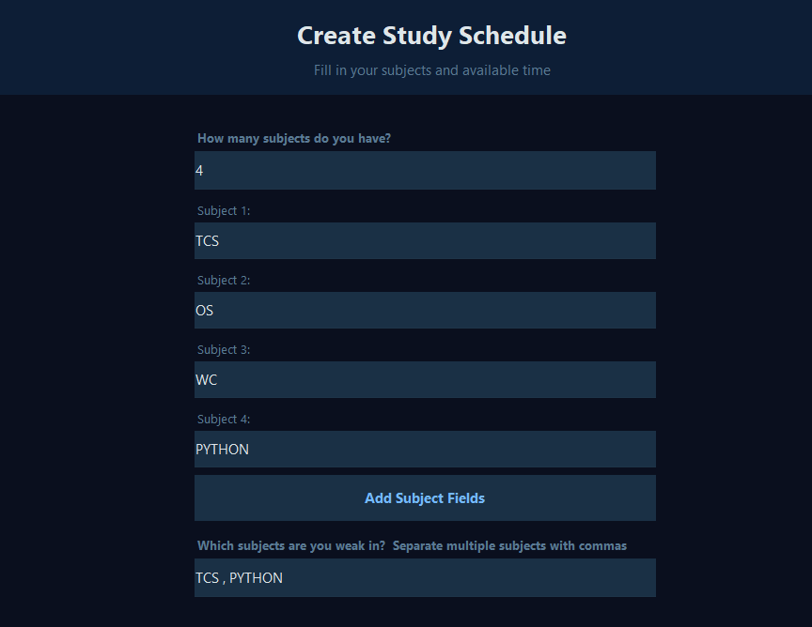
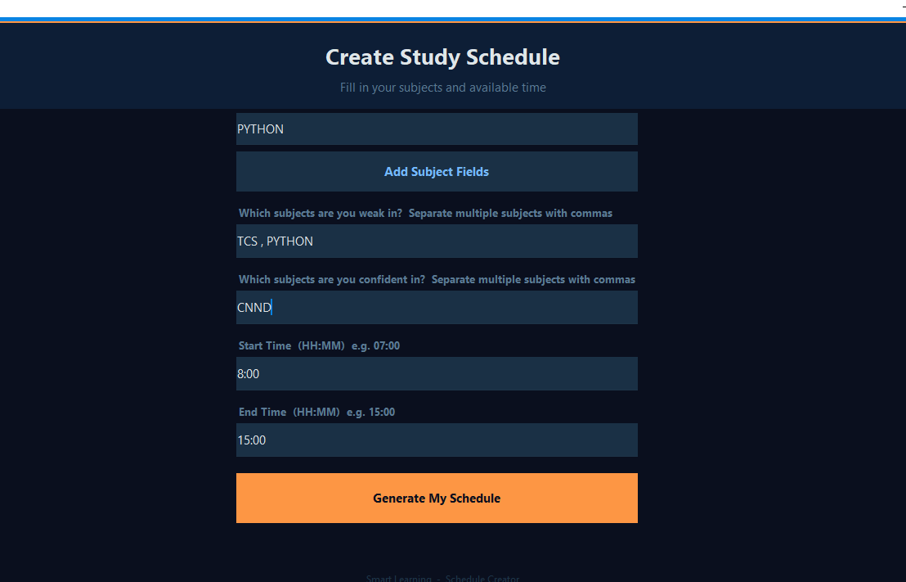

🔴 Enter Weak Subjects
Example:
Math, Physics

🟢 Enter Confident Subjects
Example:
English, History

⏰ Enter Time Range
- Start Time: 07:00
- End Time: 15:00

⚠️ Important Rules
- ❌ No duplicate subjects
- ❌ Weak subjects must match subject list
- ⏰ End time must be greater than start time

✅ STEP 4: Generate Schedule
Click:
👉 “Generate My Schedule”

👁 OPTION 2: VIEW SCHEDULE

📅 STEP 5: Understand Timetable
- Rows → Time slots ⏰
- Columns → Days 📆
- Cells → Subjects / Breaks
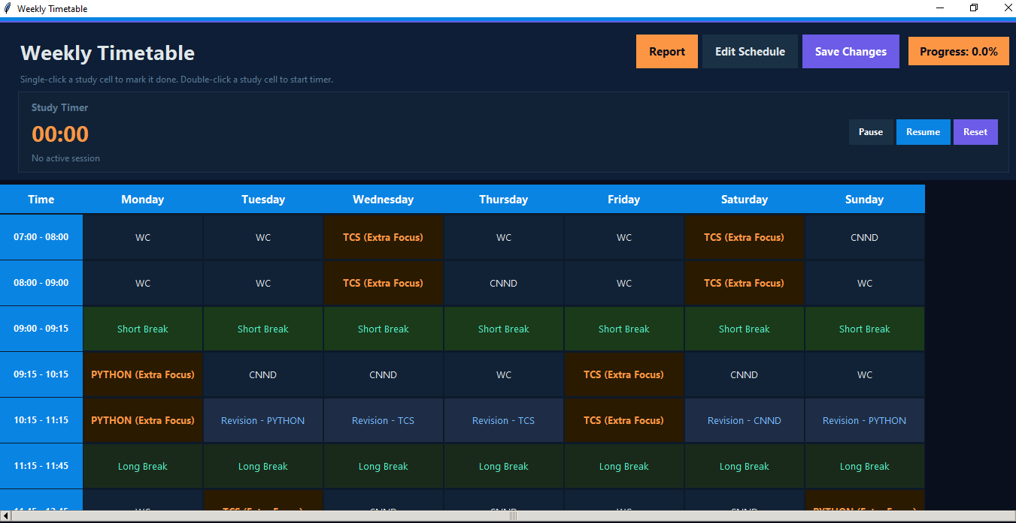
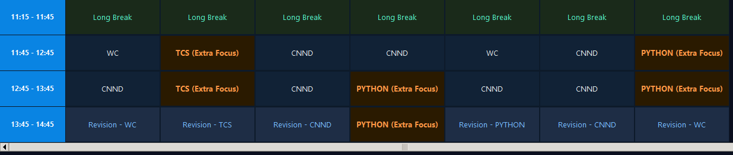

🎨 Color Indicators
- 🟢 Green → Completed
- 🔵 Blue → Revision
- 🟠 Orange → Extra Focus
- 🌿 Light Green → Break


🖱 STEP 6: Mark Task as Done
- Single-click on any study cell
Result:
Done - Subject Name
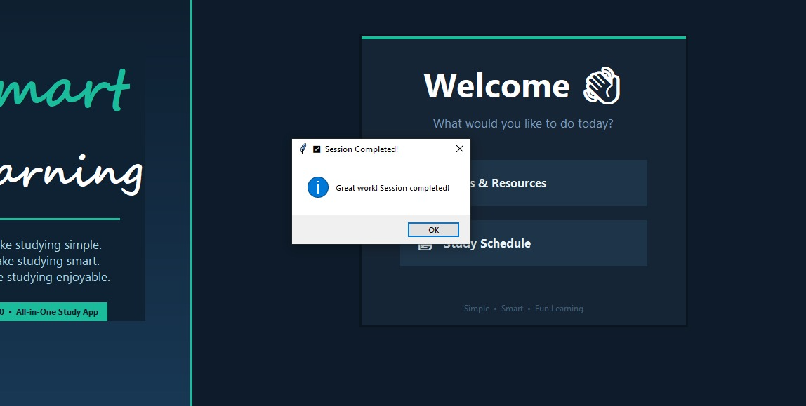

▶️ STEP 7: Start Study Timer
- Double-click on a study cell
👉 Timer starts automatically ⏱
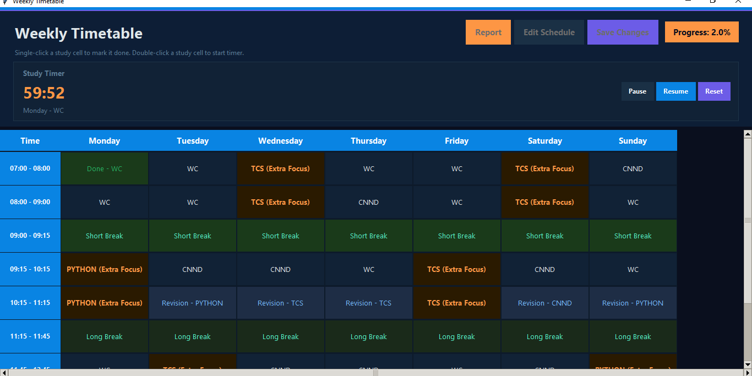

⏱ STEP 8: Timer Controls
- ⏸ Pause
- ▶ Resume
- 🔁 Reset
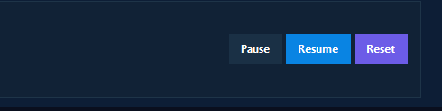

❄️ STEP 9: UI Lock Feature
- While timer is running:
  - ❌ Cannot click other cells
  - ❌ Cannot close window
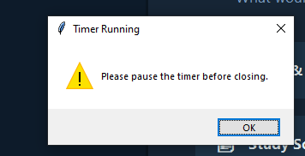

💾 STEP 10: Save Progress
Click:
👉 “Save Changes”

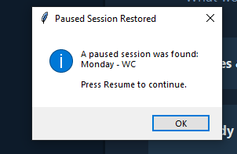

✏️ STEP 11: Edit Schedule
Click:
👉 “Edit Schedule”

📊 STEP 12: View Report
Click:
👉 “Report”
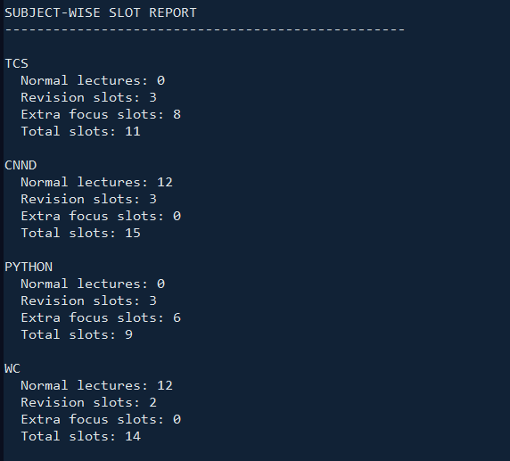

📊 OPTION 3: ANALYZE TIMETABLE

📈 Output Includes
- Total study slots
- Break slots
- Revision slots
- Extra focus slots
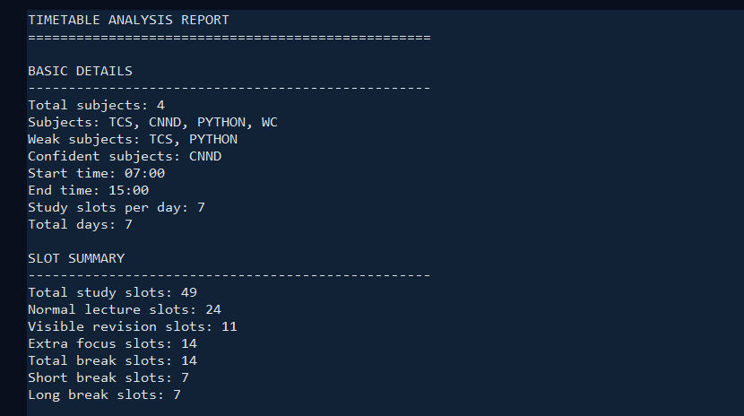

🌟 FEATURES

📊 Progress Tracking
- Shows completion percentage
📸 [IMAGE 18: PROGRESS DISPLAY]
Caption: Figure 18 – Study progress indicator

🔁 Timer Resume Feature
- Automatically restores paused session
📸 [IMAGE 19: RESUME POPUP]
Caption: Figure 19 – Resume previous session

